**Python 2 Group Assignment Checklist**

1. **Deliverables:**

* + A zip file with all code and datasets used for the projet
  + Jupyter Notebook (changing only the Group Project - Risk Based Segmentation provided)
  + Class inside RiskDataFrame.py
  + Datasets (Autoloans, column key)

## Mandatory Tasks:

* **Project Name**
* **Project Managment (Github)**
* **Implementation**: Discuss in group and decide the implementation you need to do for each method (missing_not_at_random and find_segment_split), then do the implementation of missing_not_at_random and find_segment_split. Your implementation should work in any dataset (make the necessary assumption and inform the user if the assumption are not followed, for example: inform the dataset must be clean and types must be informed in case they are not).
* **Video**

1. **Improvements**:

* **Improving**:
  + **Reliable**: Create a train-test split, train all models in train and test all models always in test;
  + **Robust:** Research and apply a statistical test to decide when the accuracy diffrence in statiscally relevant.
  + **Small functions/methods:** Break your implementation into small functions/methods;
  + **Fast:** Optimize your code, use vectorization when possible. Use stratified random sampling to reduce dataset sizes and therefore speed up the segmentation process.
  + **Tree algorithm** to mplement segmentation split
* **Publishing**:
  + Publish your code in GitHub - Work in group using Github, invite professor [manoelgad@gmail.com](mailto:manoelgad@gmail.com) as a collaborator to your project from the very beggining.
  + Create a python package and distribute your package using <https://pypi.org/>, by the end of the project one must be able to pip install your project and use it. References: <https://www.youtube.com/watch?v=GIF3LaRqgXo>; and <https://github.com/judy2k/publishing_python_packages_talk>

1. RiskDataFrame.py **Class:**

* Class inside RiskDataFrame.py
* Nico's great initial code
* data cleanning and data preparation is out of the scope of the Class, but notice that .missing_not_at_random() requires the data to have missing values

Class Methods:

* **missing_not_at_random** method

* **find_segment_split** method
* **set_ type method:** Make sure you use it inside the methods if you need this information, if you already transformed the data update this part.

1. **Jupiter Notebook:**

* **5.1 Data Cleaning & Data Preparation:**
* **5.2 Class methods Implementation:**

You can implement more methods if you think it is necessary.

the class assumes that the data is clean and ready for modelling (all variables are numeric, and dummies are already provided)

* 5.2.1 Implement a method .**missing_not_at_random()**

result is a print:

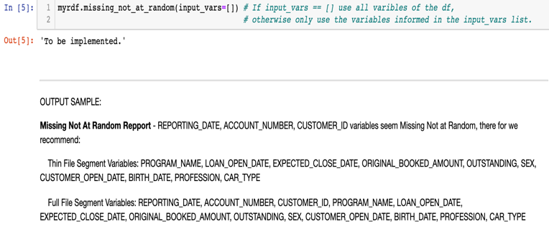

## 5.2.2 implement a method .find**_segment_split(variable)**

given one variable, implement a method to identify if the variable is a good segmentation splitter and if the variable is a good splitter,

* Scope: data cleanning and data preparation is out of the scope of the Class, note that .find_segment_split(VARIABLE) assumes the data is already clean free of missing values.
* Categorical: for the segmentation process of categorical variable, dummy transformation is not practical, it is recommended that categorical variables come pre-transformed into numerical by replacing the categories by the Probability of belonging to class 1.
* The following code only works for a single variable, implement a loop going over each variable of the dataset as a candidate for segmentation.
* The following method must implement two segmentation approaches, one for Categorical Nominal (order not relevant - variable must be automatically transformed) and others where order is important.

* + **Final report:**
* **Printout**

